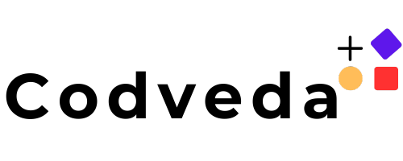



Full-Stack Development

**Content**

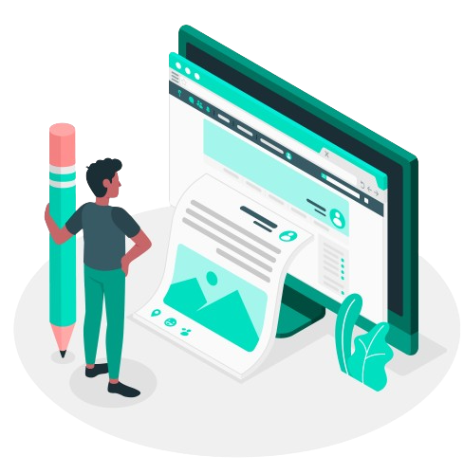

1. About Us
2. Instructions
3. Submission
4. Task List

About Us

Welcome to Codveda Technology, where innovation meets excellence. Founded with a vision to empower businesses through cutting-edge IT solutions, we specialize in delivering tailored services that drive success in the digital era.

At Codveda, we offer a diverse range of services, including web development, app development, digital marketing, SEO optimization, AI/ML automation, and data analysis.

Our team of skilled professionals is committed to helping businesses unlock their full potential by providing innovative, scalable, and reliable solutions.

# INSTRUCTIONS



Update your LinkedIn profile with your achievements, including the offer letter and completion certificate. Mention and tag @Codveda in your posts.

Use hashtags like #CodvedaJourney, #CodvedaExperience, and #FutureWithCodveda to showcase your progress and experiences.

Share your project completion updates on LinkedIn, accompanied by a video explanation and the GitHub project repository link.

You will be provided with four tasks. Select and complete any three tasks within your domain to fulfill the internship requirements.

Submit your completed tasks via the Codveda submission form. Ensure all tasks are submitted within the allocated 15- day period.

# SUBMISSION



Create a professional video showcasing your internship projects and achievements.

Host the video on LinkedIn to provide proof of your work and establish credibility among your peers. Consider tagging Codveda Technology in your posts to ensure they are notified of your work using hashtags like #CodvedaAchievements and #CodvedaProjects.

A SUBMISSION FORM will be shared later. Till then, please continue your tasks and maintain a separate file for each level. When posting the video on LinkedIn, include engaging content that highlights your contributions and skills. Tailor the post to your specific internship domain to maximize impact and visibility.

**Level 1 (Basic)**

## Task 1: Setup Development Environment

 Set up your full-stack development environment with essential tools such as Node.js, npm/yarn, a code editor (VS Code), and a version control system (Git).



## Objectives:

 Install and configure Node.js and npm/yarn.

 Set up a GitHub repository and learn basic Git commands.

 Install a database (MongoDB/MySQL/PostgreSQL).  Learn basic terminal commands.

## Task 2: Build a Simple REST API

**Level 1 (Basic)**

 Develop a simple REST API using Node.js with Express.

Create basic CRUD (Create, Read, Update, Delete) operations on a resource (e.g., users, products).

## Objectives:

 Set up an Express server.

 Create API routes for CRUD operations.

 Use Postman or Thunder Client to test API endpoints.  Handle errors and return proper HTTP responses.

## Task 3: Frontend with HTML, CSS, and JavaScript

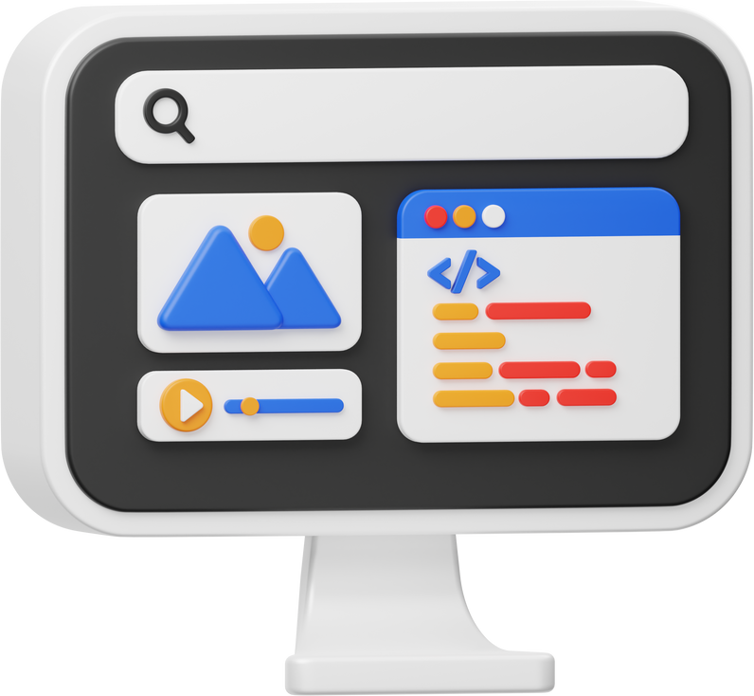

**Level 1 (Basic)**

 Create a simple frontend webpage using HTML, CSS, and vanilla JavaScript that interacts with your REST API.

## Objectives:

 Build a static website layout.

 Fetch API data using JavaScript (Fetch API/Axios).  Display fetched data dynamically on the webpage.  Use CSS for basic styling and responsiveness.

## Task 1: Frontend with a JavaScript Framework (React/Vue/Angular)



**Level 2 (Intermediate)**

 Recreate your frontend using a modern JavaScript framework for better component-based development.

## Objectives:

 Set up a project with React, Vue, or Angular.

 Use functional components and state management.  Implement API calls and handle loading states.

 Create reusable UI components.

## Task 2: Authentication and Authorization



**Level 2 (Intermediate)**

 Implement user authentication (signup, login) using JWT (JSON Web Tokens) in your backend and secure routes based on user roles.

## Objectives:

 Implement user authentication using bcrypt and JWT.

 Store tokens securely (HTTP-only cookies/local storage).

 Protect routes and restrict access based on user roles.

 Hash passwords before saving them in the database.

## Task 3: Database Integration

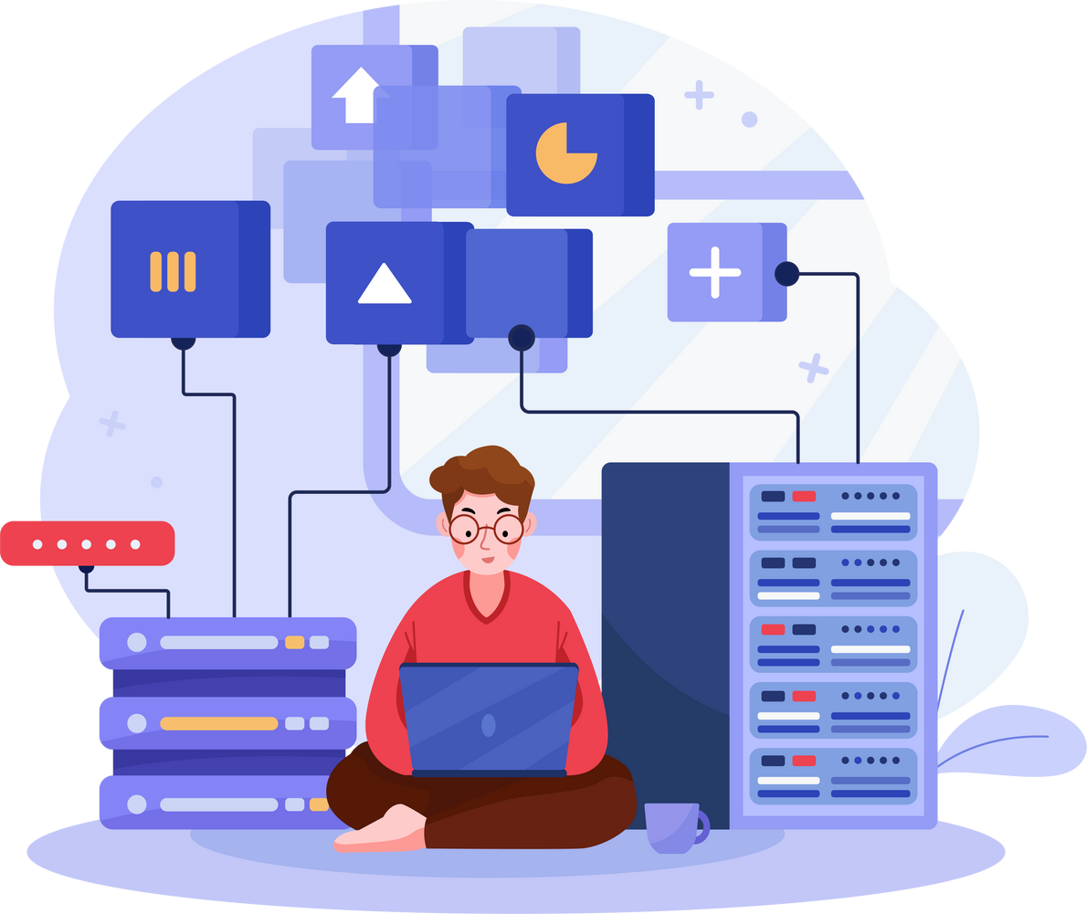

**Level 2 (Intermediate)**

 Integrate a database (MongoDB/MySQL/PostgreSQL) and perform CRUD operations on stored data.

## Objectives:

 Use MongoDB with Mongoose ORM or SQL with Sequelize/Prisma.

 Create models and relationships between collections/tables.

 Implement database indexing and optimization techniques.

 Perform data validation before saving records.

## Task 1: Build a Full-Stack Application (MERN/MEVN/PERN)



**Level 3 (Advanced)**

 Create a fully functional full-stack application that includes authentication, database interaction, and frontend integration.

## Objectives:

 Develop a fully integrated web application.

 Implement user authentication and role-based access.

 Deploy both frontend and backend.  Ensure performance optimization.

## Task 2: WebSockets for Real-Time Communication

**Level 3 (Advanced)**

 Implement WebSockets using Socket.io to create real- time features like chat applications or live notifications.

## Objectives:

 Set up WebSockets with Express and a frontend framework.

 Handle bidirectional real-time communication.

 Implement user-specific notifications/messages.  Optimize real-time data updates efficiently.

## Task 3: GraphQL API Development

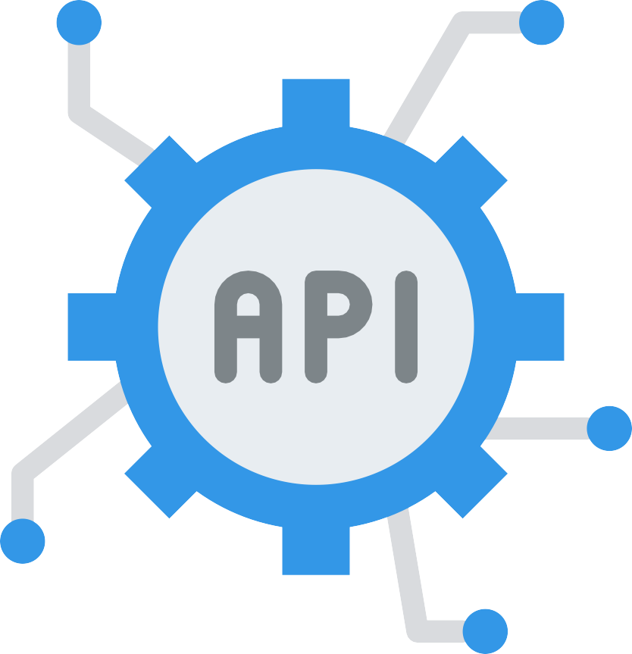

**Level 3 (Advanced)**

 Build an API using GraphQL as an alternative to REST for efficient data fetching.

## Objectives:

 Set up a GraphQL server with Apollo or Express- GraphQL.

 Define queries, mutations, and resolvers.  Handle authentication in GraphQL APIs.

 Optimize database queries with GraphQL best practices.

**How to Contact Us?**

For additional information, kindly

get in touch with our team.

[@codveda](https://www.linkedin.com/company/codveda-technologies/about/) [support@codveda.com](mailto:support@codveda.com) [www.codveda.com](http://www.codveda.com/)